By Ken Keis, MBA

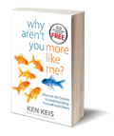
Self-Awareness: The Key to Transformation

Awareness: An awareness of one's own personality or individuality

Let me ask you this question.
If nothing changed in your life in the next 5 years,
would that be okay?

I mean everything in your life—your health, your relationships, your friends, career, feelings of fulfillment, achievement, and so on.

Let’s move the calendar ahead 5 years.

- You are the same person.
- The conditions in your life are the same as they are today.

Is that okay?

For the majority of you, it would not be.

Many of you have heard the definition of insanity which is to continue to do the same things over and over and expect different results. If you want different results, you must change what you are doing and/or the way you are doing it.

Before you can act with purpose and direction, you must understand what you need to change and how to go about it.

When we are not self-aware about our own preferences, gifts, talents, and tendencies, it is impossible for us to act intentionally. If we are not aware, we are living life—day after day and year after year—oblivious to our thought patterns and beliefs.

All of us have met people who are completely unaware that their behavior and conduct are inappropriate. They have no clue that they are clueless.

A frequent traveler, I spot unawareness on every trip . . .
- people who stop at the bottom of an UP escalator, staring into space, with no idea they are holding up the line of fellow travelers that is forming behind them, and
- people who let their carryon bags hit each seated person in the head as they make their way down the aisle.

In his book, Excuses Be Gone, Wayne Dyer said it well.

The reason why awareness of awareness is so powerful is that it immediately puts me in touch with a dimension of myself that knows that: here in awareness, all things are possible.

Wayne went on to quote a Harvard Study that tracked 84 female room-attendants who were working in different hotels.

The women were divided into two groups.

- For the control group, it was business as usual.
- The second group was told that their work was “exercise.”

- The control group experienced no improvements, despite engaging in the same physical activities as the second group.

- The ladies who recognized their work as exercise experienced significant health benefits. In just 4 weeks, they dropped weight and lowered their blood pressure, body fat, and body mass index.

That study reveals that our attitude—which is linked to our awareness—can have profound effects on our well-being.

Awareness of our beliefs is one thing.
- What about awareness of our style preferences and all the implications they have in every part of our daily lives?

A study conducted by Talent Smart discovered that less than 30% of the population has a solid understanding of their own style preferences.

About 70% of the population has no inkling of how they appear to and interact with others. They have little idea of their strengths and skills and without knowing what they are, they cannot implement them properly. The 70% who were oblivious about their Personal Style had considerably more difficultly handling stress and interpersonal relationships.

The study compared people’s levels of self-awareness to their ability to achieve the things they found most important in life.

- Satisfaction with life increases dramatically when we are self-aware.

- People who are self-aware are far more likely to reach their goals.

- Aware individuals take time to first learn then understand their Personal Style so they can better respond to life’s challenges and opportunities.

- Because they understand their situation and can identify the people that will help make them successful, they can more easily implement the right strategies.

- They also understand their limitations and adjust their attitude and behavior accordingly, to minimize any negative impact.

- They know what they really want; their awareness motivates them to take the best steps and actions to get where they want to be.

Self-awareness is so predominant to success, it transcends age, intelligence, education, profession, and job level. The Talent Smart study found that 83% of top performers are high in self-awareness—no matter the industry or profession, yet just 2% of low performers possess that critical skill.

The reality is that individuals who understand their style preferences and tendencies are much more likely to play to their strengths at work and home, limit the negative impact of their deficiencies, and get the results they desire.

When you become aware, you cease being a victim of your circumstances. You own your own space.

In my younger years, I was not self-aware. During my first few months of college, I learned the power of self-awareness. It was my first time away from home and out of town and let’s say I let loose. I became boisterous and loud in an attempt to be the center of attention. My quest was to have people like me, but the outcome of my actions was the opposite: Oh, no! Here comes Ken!

About 3 months into my first semester, I had a chance to sit down and have a couple of drinks with one of the sharp girls in our dorm. Thirty minutes into our conversation, she said, “You are not a jerk after all. In fact, you are a really nice guy.”

In complete shock, I asked her what she meant.

“Ken, you are loud, sometimes obnoxious. You try way too hard. It really is quite irritating. But in this conversation today, you are calm, interesting, and focusing on our discussion.”

I was immature and unaware that my actions were driving people away, not bringing them closer.

You don’t have to be in college to be self-aware. When my son Tim was in Grade Eight, we started to coach him on the impact his Personal Style was having in his environment. We were creating self-awareness in him.

Tim’s style is active and verbal, contrary to the learning model in education that wants everyone to be compliant and quiet. A lot of tension had developed between my son and one of the younger, less experienced teachers. Her response to Tim’s verbal nature was to try to put tighter controls on him, which exasperated the situation. She was not aware, either.

We coached him to manage his verbal nature and tone it down a bit. We did not want to change who he was, but we wanted him to be aware that his verbal energy was disrupting the class. Less than a week later, he burst through our door at home, excited to tell us that class was going a lot better. I asked how he was achieving that excellent result. “Dad,” he said, “I learned how to shut up!”

Tim was so proud of his ability to manage the self, while being self-aware. If a 14-year-old can do that, anyone can.

Square Wheels

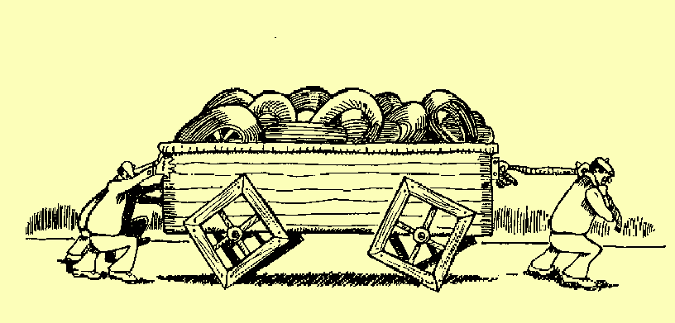
Used with permission by www.squarewheels.com

When you look at the image of the wagon with the square wheels, what do you see and think?

- What do the square wheels represent as a metaphor for our lives—home and at work? Some might answer with words like struggle, difficult, inefficient, challenge, hard, toiling, stuck—even silly.

- What about the people in behind the wagon? What do they see? Only the back of the wagon! What is their perspective on life and this situation? For sure, it’s limited.

- What about the person pulling the wagon? What is he thinking and experiencing? Is he wondering if anyone will come along to help? He’s not looking back to see if there is any way to improve the situation.

- And what about the round wheels inside the wagon? What do they represent? Do words like opportunity, improvement, easier way, upgrade, progress, a different way of doing things come to mind?

Some questions must be asked.

- Why are they stuck—both the leader and the followers?

- Why don’t they put the round wheels on the wagon or at least consider doing that?

- How far away are the round wheels? The wheels are readily available but the leader and the followers are unaware of the opportunities.

Have you ever met someone who is dealing with a problem and the answer to his dilemma is obvious—right in front of his eyes—but he still doesn’t get it? The answer he seeks is right there but he can’t, or won’t, see it. He is completely oblivious to the opportunity.

I admit in the past to being quick to judge when individuals did not see the obvious. I now understand it was not obvious to them. Rather than standing in judgment, let’s move to helping and coaching people to see their prospects.

After more than 20 years of serving others in the field of personal and professional development, I see many situations like the one depicted in the second illustration below.

A caterpillar tractor is now pulling the square-wheeled wagon!
- Here’s their thinking: Let’s commit ourselves 100% to our square wheels. Let’s take what has not been working and do it harder.

I see it every week in individuals, families, teams, organizations—even governments—that dedicate themselves to their square wheels. They embrace the certainty of misery rather than the misery of uncertainty.

If you look closely at the second illustration, you’ll notice that arrows are sticking out of the caterpillar driver’s back. The blind devotion to broken, unproductive habits causes pain to everyone concerned.

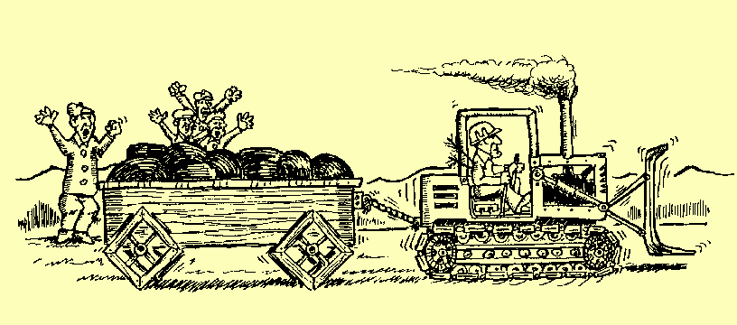
Used with permission by www.squarewheels.com

So what about you?

- Where in your life—as it pertains to personal and interpersonal effectiveness and career fulfillment—are you holding onto square wheels?

- Where have you blindly—without conscious intention or awareness—stayed committed to your square wheels?

Here’s my challenge to you all . . .

Everyone has a few square wheels—myself included. Rather than protecting the status quo, I am encouraging you to start looking for and using round wheels. As you can see, the round wheels are within reach—if you choose to embrace change using new information.

Be aware that to live a satisfying, fulfilled, and successful life, understanding your Personal Style and the styles of others is not an option. It is essential!

Self-awareness without action is not beneficial to anyone. Like anything else, if you don’t use it, you lose it. By exercising your knowledge, you have the opportunity to transform not only your life, but the lives of others along the way.

Note: By completing a Personal Style Indicator, you will learn about your Personal Style preferences and patterns and the other factors that constantly influence your reality.


Ken Keis is considered a global authority on the way assessment strategies increase and multiply your success rate. In 24 years, he has conducted more than 2500 presentations and 10,000 hours of consulting and coaching. Author of Why Aren’t You More Like Me? Discover the Secrets to Understanding Yourself and Others, Ken has co-created CRG’s proprietary development models and written over 3.5 million words of content for 40 business training programs and 400+ articles. Ken’s expertise includes assisting individuals, families, teams, and organizations to realize their full potential and to live On Purpose! Contact Ken at 604 852-0566, info@crgleader.com, or through www.whyarentyoumorelikeme.com.

